# [**Mariska Hargitay & Christopher Meloni's Latest Reunion Will Give Law & Order Fans All the Feels**](https://www.eonline.com/amp/news/1172023/mariska-hargitay-christopher-meloni-s-latest-reunion-will-give-law-order-fans-all-the-feels?__twitter_impression=true&s=09)

The former *SVU* co-stars got together over the weekend and the photos are just too precious!

**By** [**BRETT MALEC**](https://www.eonline.com/authors/brett-malec) **JUL 20, 2020 5:03 PM**

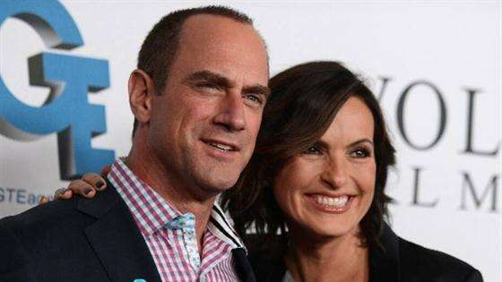

**Related:** Mariska Hargitay Welcomes Chris Meloni Back to "Law & Order"

Benson and Stabler are back together...again!

Over the weekend, former *Law & Order: Special Victims Unit* co-stars **Mariska Hargitay** and **Christopher Meloni** had another real-life reunion and the photos are just *too* cute! The Emmy-winning actress took to Instagram on Sunday to share images of her and her BFF enjoying some fun in the sun.

"It's on," Hargitay wrote, followed by another caption that read, "Easy like Sunday mornin..."

The two photos show the besties smiling as Meloni wraps his arm around Hargitay. The duo appear to be wet after taking a dip in the pool.

Hargitay and Meloni's latest adorable hang-out comes ahead of [**their upcoming on-screen reunion**](https://www.eonline.com/news/1168294/christopher-meloni-on-return-to-law-order-and-quot-inherent-drama-quot-between-benson-and-stabler).



[**READ**](https://www.eonline.com/news/1171237/who-is-law-and-order-svus-best-ada-vote-now)

[**Who Is *Law and Order: SVU*'s Best ADA? Vote Now!**](https://www.eonline.com/news/1171237/who-is-law-and-order-svus-best-ada-vote-now)

It was [**announced back in March 2020 that Meloni would be reprising his role as Elliot Stabler**](https://www.eonline.com/news/1136218/christopher-meloni-returning-to-law-and-order-fold-with-new-series-as-elliot-stabler), the *SVU* character he played for 12 years, on a new spinoff series *Law & Order: Organized Crime*. Meloni is set to return to *SVU* in the season 22 premiere and then appear in the NBC spinoff.

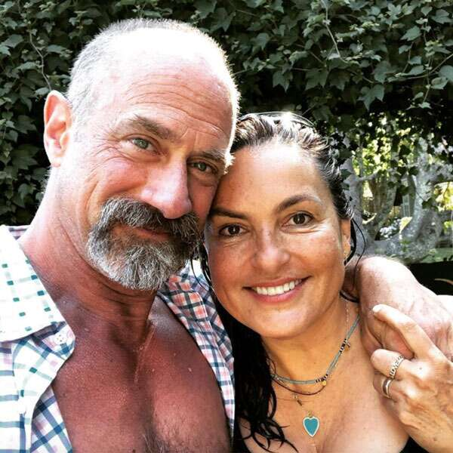Instagram

As *Law & Order* fans know, Hargitay and Meloni have been known to reunite pretty often, proving their real-life friendship is just as strong as their TV characters' bond. And now that NBCU's new streaming service [**Peacock**](https://www.peacocktv.com/) has launched, viewers can revisit Hargitay and Meloni's captivating *Law & Order* chemistry by binging *SVU* anytime!

Check out all of Hargitay and Meloni's reunions in the photo gallery below and watch *Law & Order: SVU* on Peacock now.

(E!, Peacock and NBC are all part of the NBCUniversal family)

#### ***TRENDING STORIES***

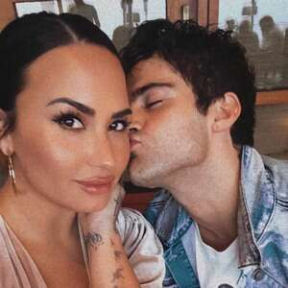

**1**

### [**Max Ehrich Reveals More Details About Demi Lovato Split**](https://www.eonline.com/news/1192405/max-ehrich-reveals-more-details-about-how-he-learned-of-demi-lovato-split)

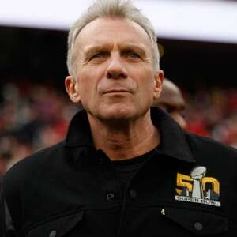

**2**

### [**Joe Montana Gives Update After Attempted Kidnapping Of Grandchild**](https://www.eonline.com/news/1192416/nfl-legend-joe-montana-gives-family-update-after-attempted-kidnapping-of-9-month-old-grandchild)



**3**

### [**Japanese Actress Yuko Takeuchi Dead at 40: Reports**](https://www.eonline.com/news/1192380/japanese-actress-yuko-takeuchi-dead-at-40-reports)

[**Peacock is live now! Check out NBCU's new streaming service here.**](https://www.peacocktv.com/?cid=20200101evergreensymseo241&utm_source=symphony&utm_medium=symphony_seo_brandawareness_articlebacklink&utm_campaign=20200101evergreen&utm_term=eonlineusers&utm_content=eonllinebacklink)

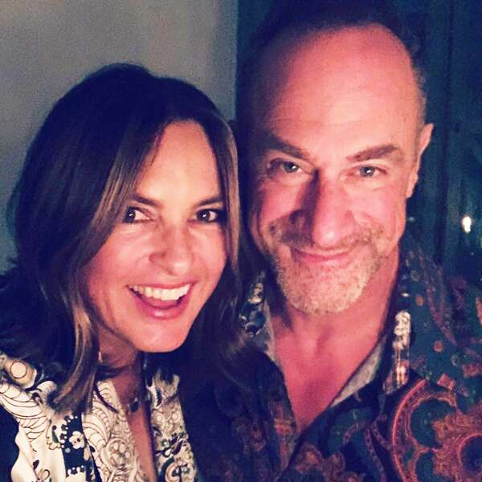Mariska Hargitay / Instagram

**Dinner Party**

"Sunday night dinner," **Mariska Hargitay** shared alongside a selfie of her and **Chris Meloni**, who she starred with on *Law & Order: SVU* for 12 seasons before the actor left the series in 2011.

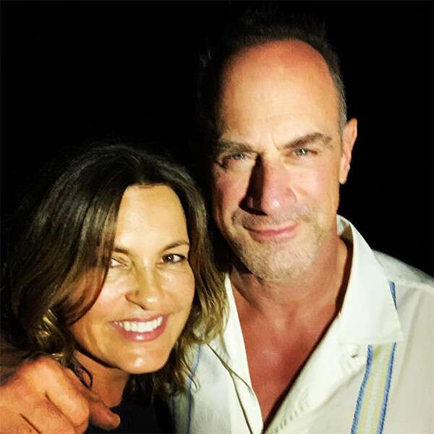Instagram

**Vacation Buddies**

Hargitay posed this [**snap**](https://www.instagram.com/p/Br_wOjRHkkn/) with her bestie while on vacation in December 2018 and we're obsessed. "Vacay...A great night with this one. #Reunited #OldFriends #PTL," she captioned it.

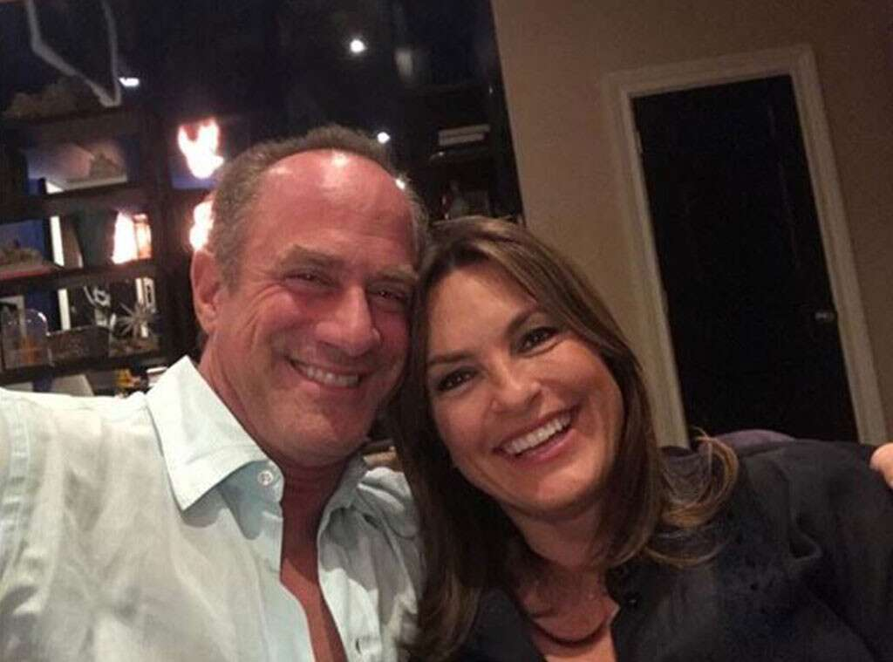Instagram

**Partners for Life**

In May 2018, Meloni and Hargitay hung out together in New York City and of course they documented it...thank goodness.

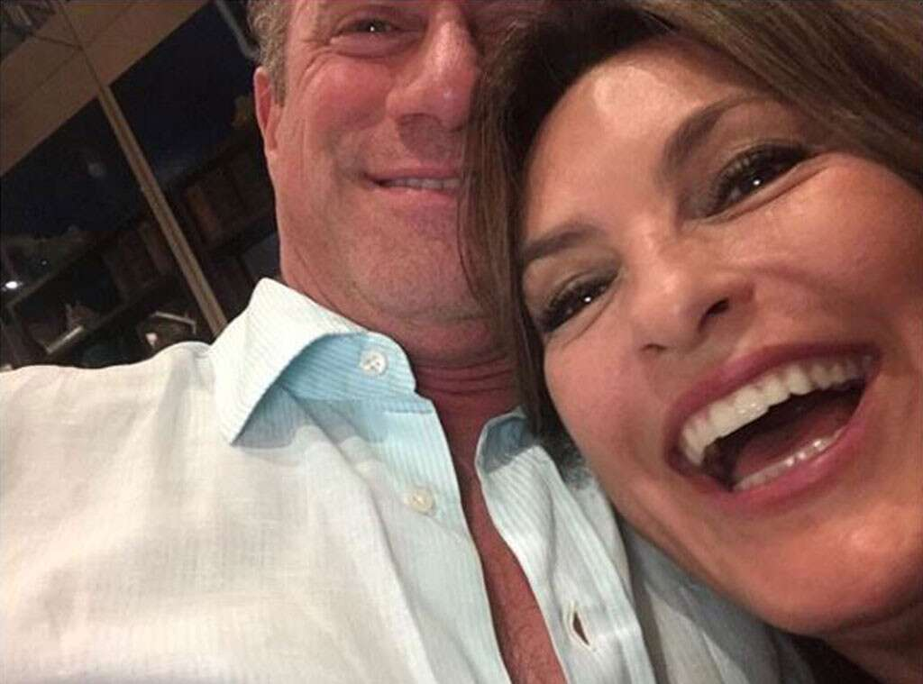Instagram

**Selfie Fail**

"Crazy ppl on the streets of nyc," Meloni [**captioned**](https://www.instagram.com/p/BjYx9bFhKgw/?taken-by=chris_meloni) this selfie fail and seriously, how can you not just love these two together?

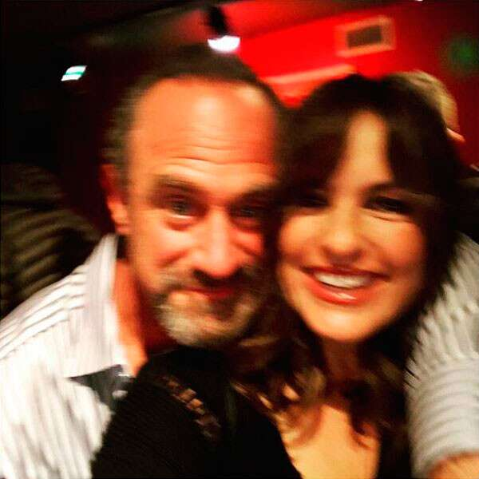Instagram

**Blurry Buds**

Blurry or not, this snap of the two former *Law & Order: Special Victims Unit* co-stars spending time together during the holidays in 2017 is too cute.

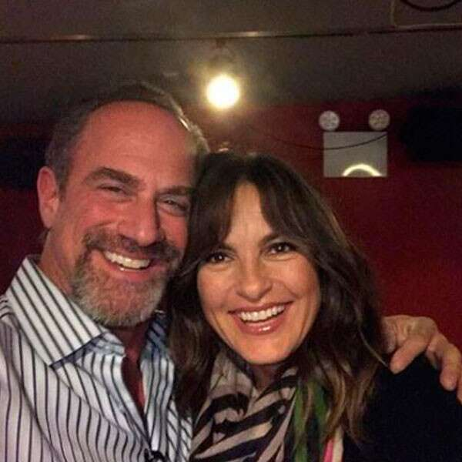Instagram

**Happy and They Know It**

After Thanksgiving in 2017, the two pals ran into one another and clearly they still have fun no matter what the occasion.

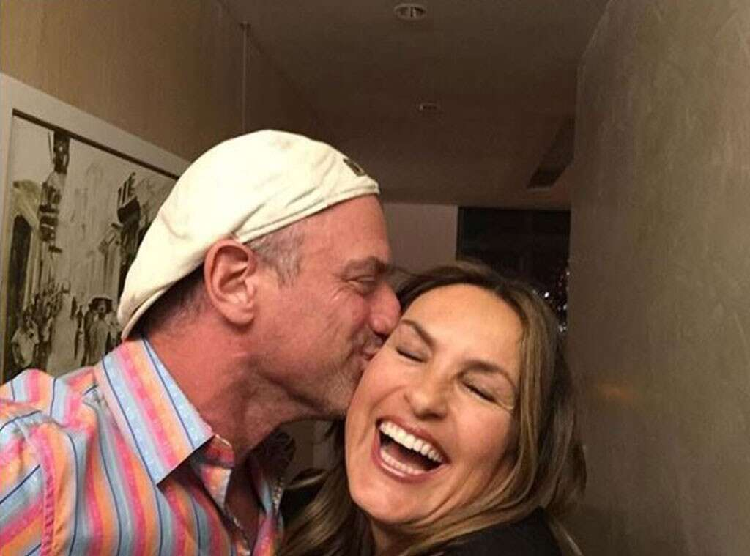Instagram

**Kiss Kiss**

Ugh, how do we get Detective Stabler to give us a smooch?

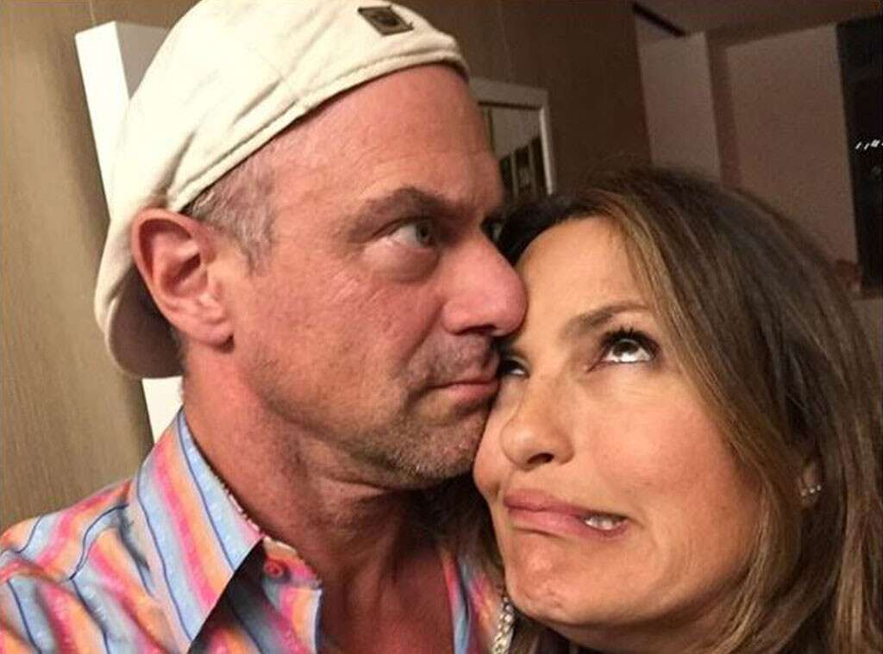Instagram

**Goofballs Forever**

"Even the effortless moments..." Meloni [**captioned**](https://www.instagram.com/p/BTcXrQfjdVQ/?taken-by=chris_meloni) the previous photo only to follow it up with this funny picture and the [**caption**](https://www.instagram.com/p/BTcXuXwje6C/?taken-by=chris_meloni), "...need to be rehearsed."

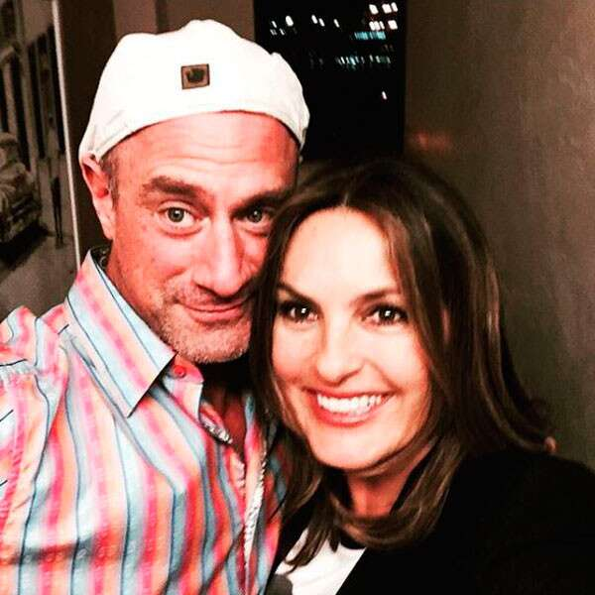Instagram

**Birthday Bash**

Hargitay shared this sweet snap in honor of her former TV partner's birthday in April 2017 and said "PFL" at the [**end of the note**](https://www.instagram.com/p/BSXouv4j8_8/?taken-by=therealmariskahargitay) and we're dying a little inside because Stabler and Benson *are* partners for life!

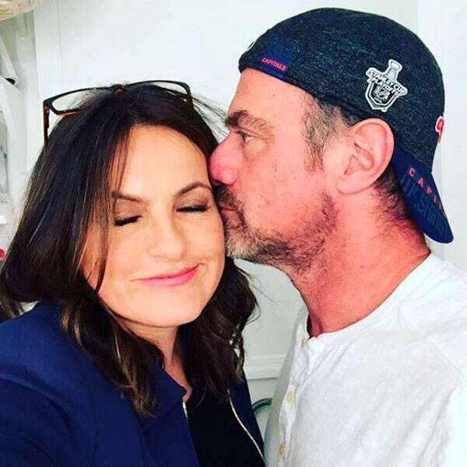Instagram

**Be Mine**

"And then that happened...Just when I thought Valentine's Day was over," Hargitay [**wrote**](https://www.instagram.com/p/BQjI-d9FF-N/?taken-by=therealmariskahargitay) alongside this kissing picture from Valentine's Day in 2017 and we are again getting teary-eyed at these two loving each other so much.

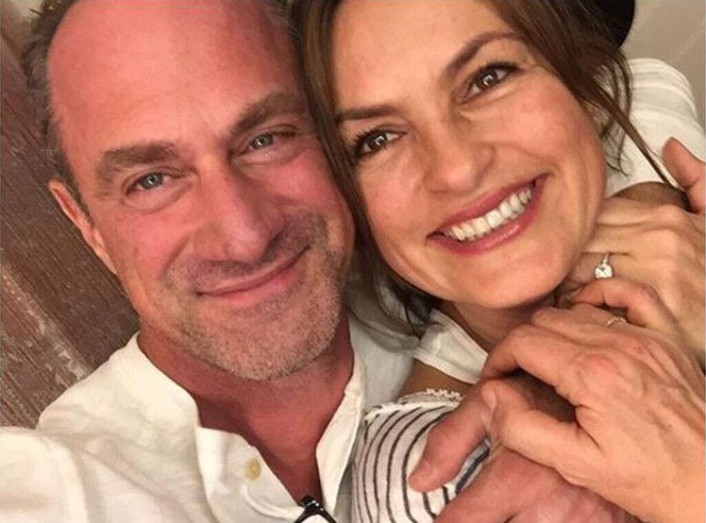Instagram

**Stabler & Benson for President**

In 2016, the former TV partners and real-life friends celebrated Christmas together (well, a few days early) and we are in desperate need of an on-screen reunion now.

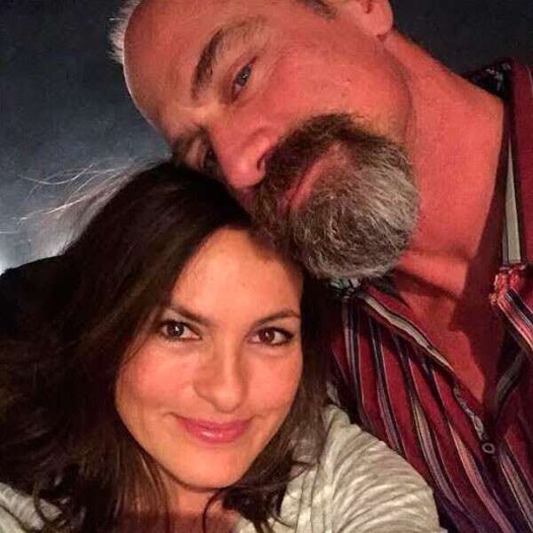Instagram

**Friendly Run-ins**

"Lean on me #PFL #FacialHairDontCare #Hargoatee #HanginWithAFriend #ItsAllInTheEyesKid," Hargitay [**wrote**](https://www.instagram.com/p/BC1BMFMkK-S/?taken-by=therealmariskahargitay) on this precious picture and we will never get tired of these quick reunions.

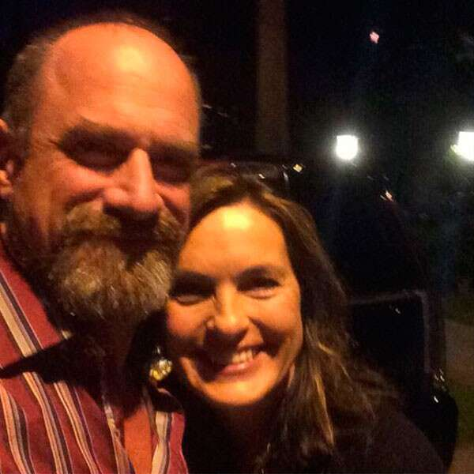Instagram

**Spotted: *SVU* Pals**

In 2015, in the dark of night, New York City's greatest detectives, err, we mean friends, reunited once again and posed for an epic photo.

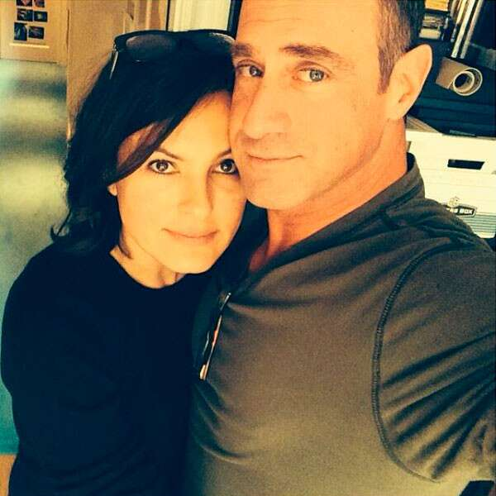Instagram

**Ride or Die**

It doesn't matter how long these two are apart, they always make time to check in with each other and we are totally on board with all the run-ins that have happened over the past few years.

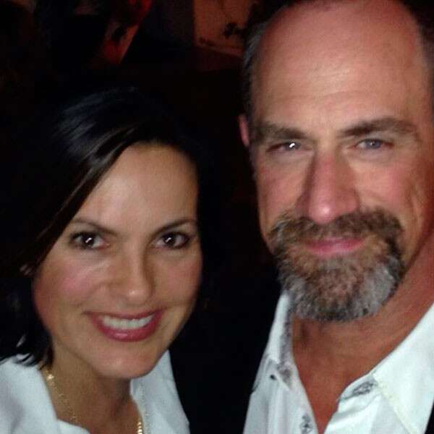Instagram

**Bestie Reunions**

In March 2014, the duo reunited for dinner proving that they will always be partners, even if they aren't acting alongside one another anymore.